**Pre Requisites-IBM Cloud Services**

|  |  |
| --- | --- |
| **TEAM ID** | PNT2022TMID08486 |
| **Project Name** | INDUSTRY SPECIFIC INTELLIGENT FIRE MANAGEMENT SYSTEM |
| **Leader Name** | RISHALIN M |
| **Team Members Name** | RAJASUSHMITHA R  RAMYA T  SAJITHA CHANDRAN S |

**DASHBOARD:**

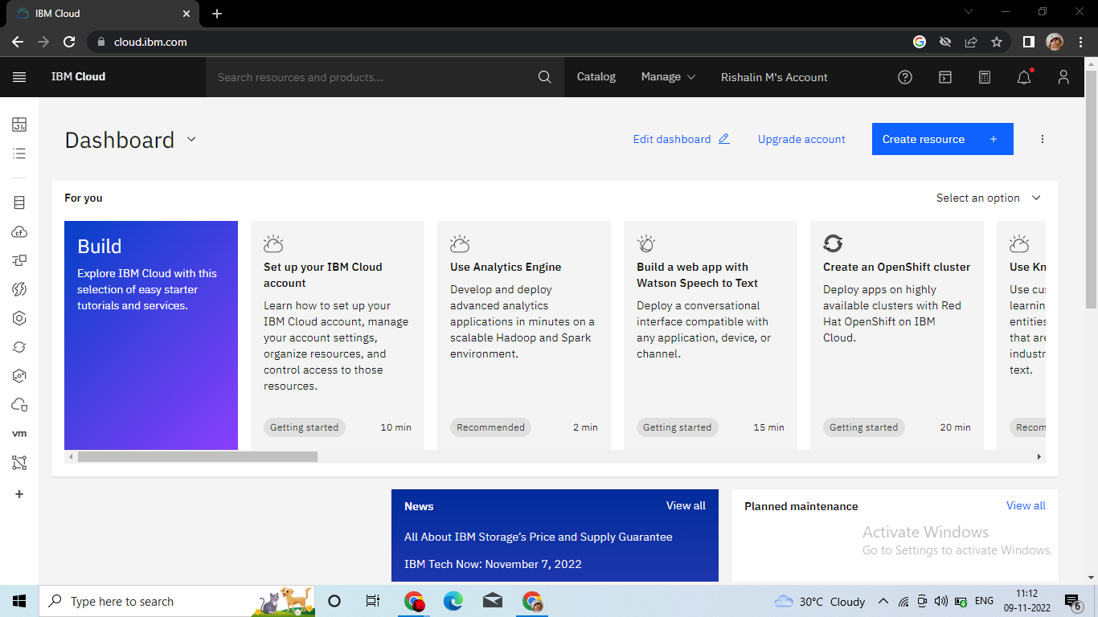

**ACCOUNT SETTINGS:**

